**Lab Introduction:**

In this lab we’ll be learning the basics of four physical topologies: Bus topology, Ring topology, Star topology and Mesh topology using a network simulation tool, Cisco Packet Tracer.

**Objectives:**

* To learn what Bus, Ring, Star and Mesh topologies are
* How these topologies work
* Where these topologies are used
* Advantages and disadvantages of these topologies

**Index**

|  |  |  |
| --- | --- | --- |
| Experiment No. | Experiment Title | Page |
| 01 | Simulating Bus Topology using Cisco Packet Tracer | 2 |
| 02 | Simulating Ring Topology using Cisco Packet Tracer | 5 |
| 03 | Simulating Star Topology using Cisco Packet Tracer | 8 |
| 04 | Simulating Mesh Topology using Cisco Packet Tracer | 11 |

**Experiment No.: 1**

**Experiment Title:** Simulating Bus Topology using Cisco Packet Tracer

**Objectives:**

* To learn what a Bus topology is
* How a Bus topology works
* Where a Bus topology is used
* Advantages and disadvantages of Bus topology

**Discussion:**

Physical topology is the geometric representation of all the nodes and interconnections in a network.

A Bus topology is a physical topology where all the nodes are connected to a single backbone cable. When a signal moves along the backbone, only the receiver receives it, and the rest ignores it.

**Methodology:**

* Create the network topology.
* Configuration of the Network Nodes.
* Choose the Statistics.
* Run the Simulation.
* Analysis of the Results.

**Working procedure:**

1. **Giving the geometric shape of the topology**

Connecting 5 Pcs to 5 switches, 1 per each, with straight through copper cable, as they are different typed devices and then connecting each switch to 1 other switch linearly with cross over copper cable, as they are same type of devices, all via Fast Ethernet ports.

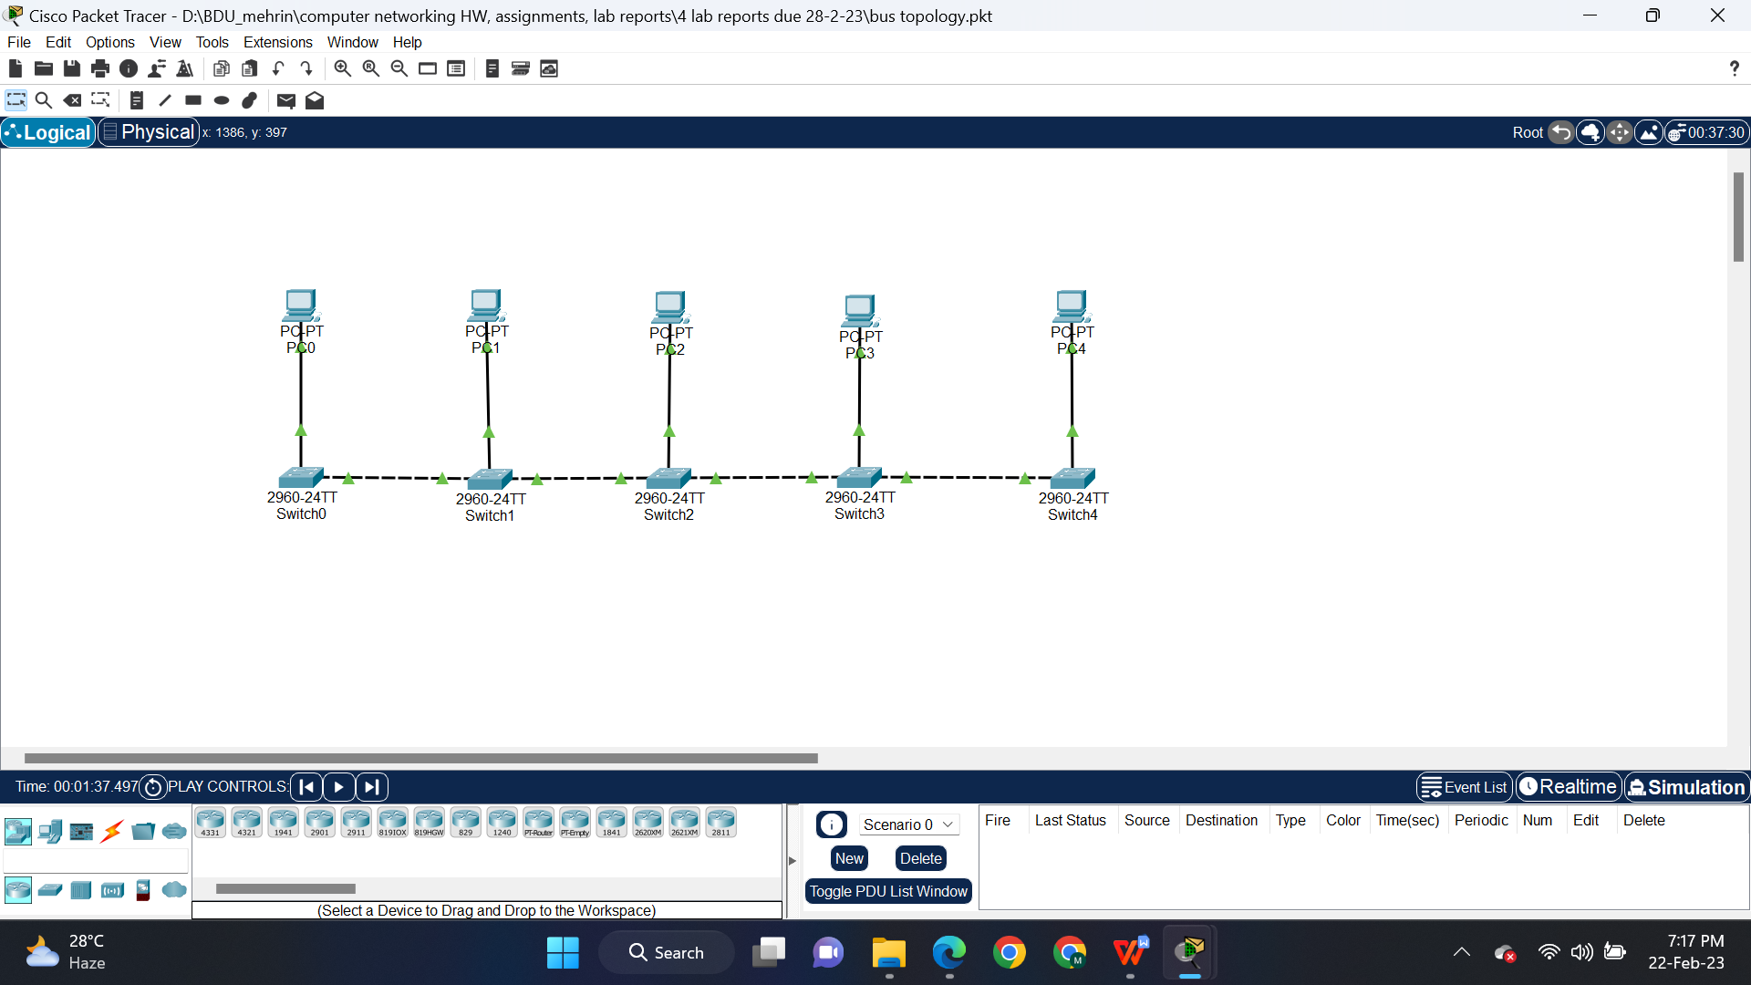

Fig 1.1: Simulating a bus topology in CPT

1. **Configuring the PCs**
   1. Configure PC0, PC1, PC2, PC3, PC4 with the following IP addresses and Subnet Masks

|  |  |  |
| --- | --- | --- |
| **Host** | **IP Address** | **Subnet Mask** |
| PC0 | 10.10.10.1 | 255.0.0.0 |
| PC1 | 10.10.10.2 | 255.0.0.0 |
| PC2 | 10.10.10.3 | 255.0.0.0 |
| PC3 | 10.10.10.4 | 255.0.0.0 |
| PC4 | 10.10.10.5 | 255.0.0.0 |

1. **Sending data across PCs**
   1. Connection tests across PCs

Ping PCs by there IP addresses from another PC in Command Prompt, one after another. If connection is there, four replies will come.

Command: ping<space>’IP address of some other PC’

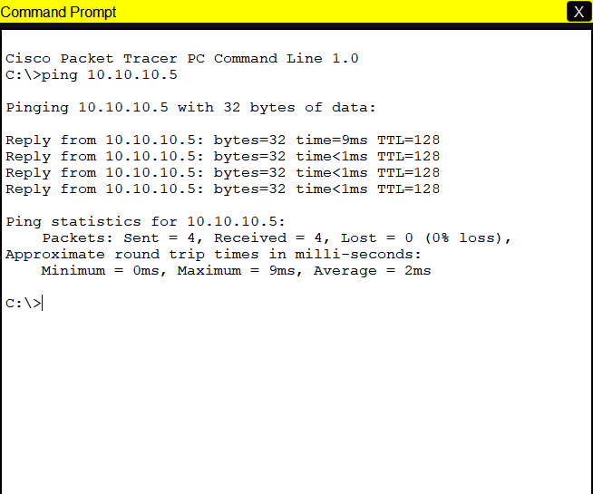

Fig 1.2: Pinging PC4 from PC0

1. **Simulation:**



Fig 1.3: Successful packets travel across PCs

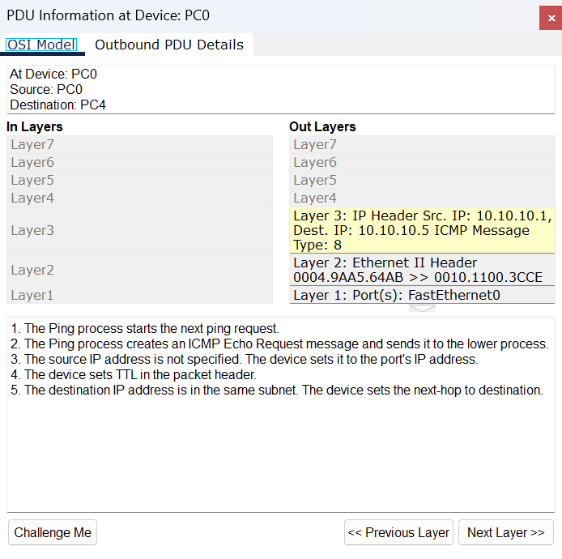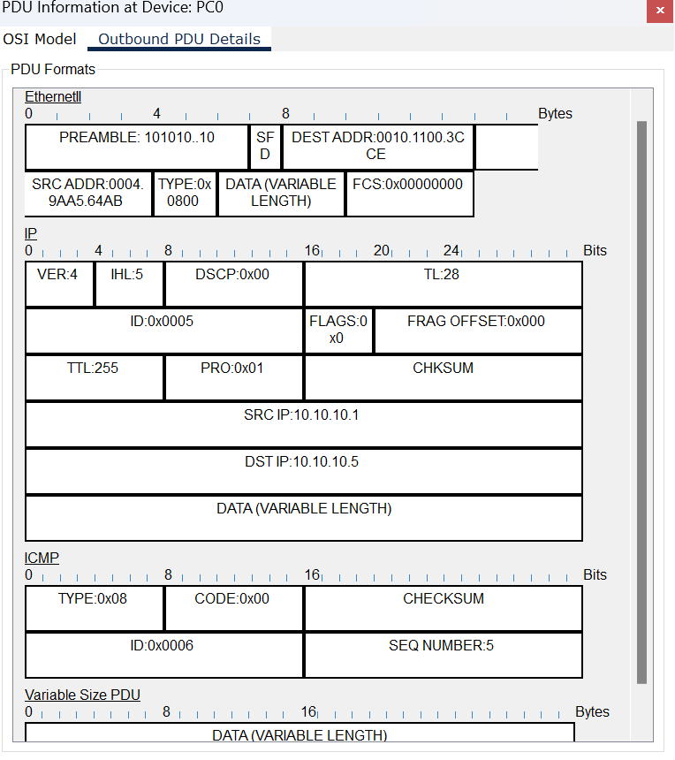

Fig 1.4: Protocol data unit at PC0

**Conclusion:**

* What a bus topology is:
* It is also called a line topology.
* Bus topology connects all station via a single cable called backbone
* How a bus topology works:
* Data travels through the backbone, through each station, but only the destination accepts the data and others reject it.
* Where a Bus topology is used:
* It is used in small networks.
* Pros and cons of using a bus topology:

|  |  |  |
| --- | --- | --- |
| Pros |  | Cons |
| 1. Easy to manage in a small network, economical and trustworthy. |  | 1. Not great for large networks. |
| 1. Needed less cable. |  | 1. Detecting faults in network is hard. |
| 1. If need be, network I.e. backbone can be extended using repeaters. |  | 1. Data transmission is slow. |
| 1. If any station stops working, the system will still operate. |  | 1. A single fault in the backbone can make the entire network to go down. |
| 1. While adding or. Taking away stations, system stays on. |  | 1. High packet loss. |

**Experiment No.: 2**

**Experiment Title:** Simulating Ring Topology using Cisco Packet Tracer

**Objectives:**

* To learn what a Ring topology is
* How a Ring topology works
* Where a Ring topology is used
* Advantages and disadvantages of Ring topology

**Discussion:**

Physical topology is the geometric representation of all the nodes and interconnections in a network.

A Ring topology is a physical topology where all the nodes are connected to 2 other nodes on both of its sides I.e neighboring nodes taking a ring form. Data travels across the network in a circular path until it reaches its destination. In this, data travels in unidirectional forms means in only one direction but it can also do bidirectional by having 2 connections between each Network Node, it is called Dual Ring Topology.

It is used in LANs and WANs.

**Methodology:**

* Create the network topology.
* Configuration of the Network Nodes.
* Choose the Statistics.
* Run the Simulation.
* Analysis of the Results.

**Working procedure:**

1. **Giving the geometric shape of the topology**

Connecting 5 Pcs to 5 switches, 1 per each, with straight through copper cable, as they are different typed devices and then connecting each switch to 2 other neighboring switches with cross over copper cable, as they are same type of devices, all via Fast Ethernet ports.

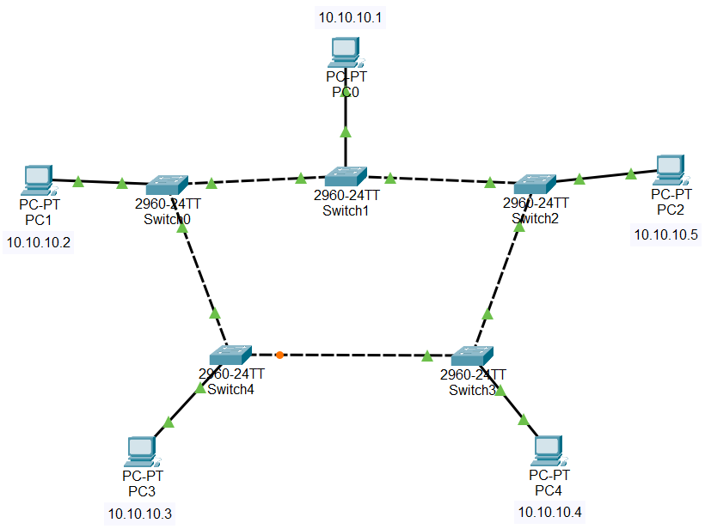

Fig 2.1: Simulating a ring topology in CPT

1. **Configuring the PCs**
   1. Configure PC0, PC1, PC2, PC3, PC4 with the following IP addresses and Subnet Masks

|  |  |  |
| --- | --- | --- |
| **Host** | **IP Address** | **Subnet Mask** |
| PC0 | 10.10.10.1 | 255.0.0.0 |
| PC1 | 10.10.10.2 | 255.0.0.0 |
| PC2 | 10.10.10.5 | 255.0.0.0 |
| PC3 | 10.10.10.3 | 255.0.0.0 |
| PC4 | 10.10.10.4 | 255.0.0.0 |

1. **Sending data across PCs**
   1. Connection tests across PCs

Ping PCs by there IP addresses from another PC in Command Prompt, one after another. If connection is there, four replies will come.

Command: ping<space>’IP address of some other PC’



Fig 2.2: Pinging PC4 from PC0

1. **Simulation:**



Fig 2.3: Successful packets travel across PCs

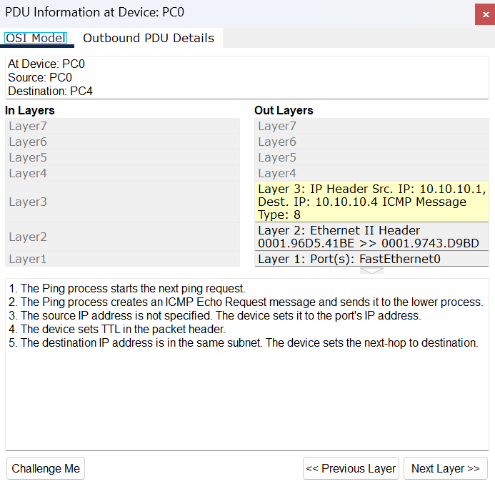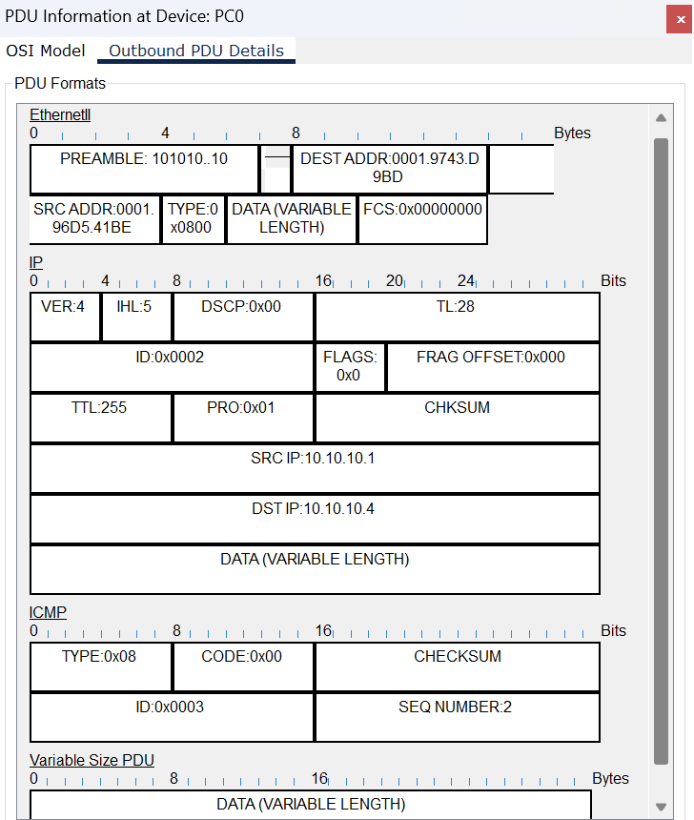

Fig 2.4: Protocol data unit at PC0

**Conclusion:**

* What a ring topology is:
* The network is also mentioned as a hoop network.
* A Ring topology is a physical topology where all the nodes are connected to 2 other nodes on both of its sides I.e neighboring nodes taking a ring form.
* In this, data travels in unidirectional forms means in only one direction but it can also do bidirectional by having 2 connections between each Network Node, it is called Dual Ring Topology
* How a ring topology works:
* Data travels across the network in a circular path until it reaches its destination.
* Where a ring topology is used:
* It is used in LANs and WANs.
* Pros and cons of using a ring topology:

|  |  |  |
| --- | --- | --- |
| Pros |  | Cons |
| 1. No need for a center station or server. |  | 1. Network falls if any station falls, as every station is dependant on every other station. |
| 1. Every connected station is equally important. |  | 1. Detecting faults is quite complex. |
| 1. Station increment does not affect its performance. |  | 1. The whole system shuts down for station addition or subtraction. |
| 1. Data flows in one direction which reduces the chance of packet collisions. |  | 1. More expensive than bus topology. |

**Experiment No.: 3**

**Experiment Title:** Simulating Star Topology using Cisco Packet Tracer

**Objectives:**

* To learn what a Star topology is
* How a Star topology works
* Where a Star topology is used
* Advantages and disadvantages of Star topology

**Discussion:**

Physical topology is the geometric representation of all the nodes and interconnections in a network.

A Star topology is a physical topology where all the nodes are connected to a single network connecting device I.e. switch or hub. When data received by the network connecting device it forwards the data only to the destination, if it is a switch, or, it forwards the data to every other nodes except the sender where only the destination node, whose IP address matches, accepts it and others ignore it, if it’s a hub.

**Methodology:**

* Create the network topology.
* Configuration of the Network Nodes.
* Choose the Statistics.
* Run the Simulation.
* Analysis of the Results.

**Working procedure:**

1. **Giving the geometric shape of the topology**

Connecting 5 Pcs to a switch with straight through copper cable, as they are different typed devices via Fast Ethernet ports.

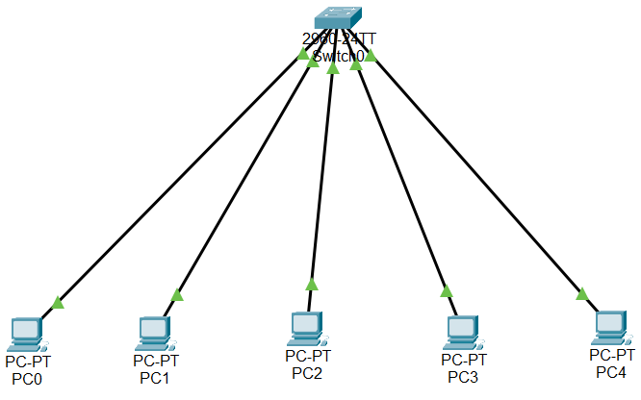

Fig 3.1: Simulating a bus topology in CPT

1. **Configuring the PCs**
   1. Configure PC0, PC1, PC2, PC3, PC4 with the following IP addresses and Subnet Masks

|  |  |  |
| --- | --- | --- |
| **Host** | **IP Address** | **Subnet Mask** |
| PC0 | 10.10.10.1 | 255.0.0.0 |
| PC1 | 10.10.10.2 | 255.0.0.0 |
| PC2 | 10.10.10.3 | 255.0.0.0 |
| PC3 | 10.10.10.4 | 255.0.0.0 |
| PC4 | 10.10.10.5 | 255.0.0.0 |

1. **Sending data across PCs**
   1. Connection tests across PCs

Ping PCs by there IP addresses from another PC in Command Prompt, one after another. If connection is there, four replies will come.

Command: ping<space>’IP address of some other PC’



Fig 3.2: Pinging PC4 from PC0

1. **Simulation:**



Fig 3.3: Successful packets travel across PCs

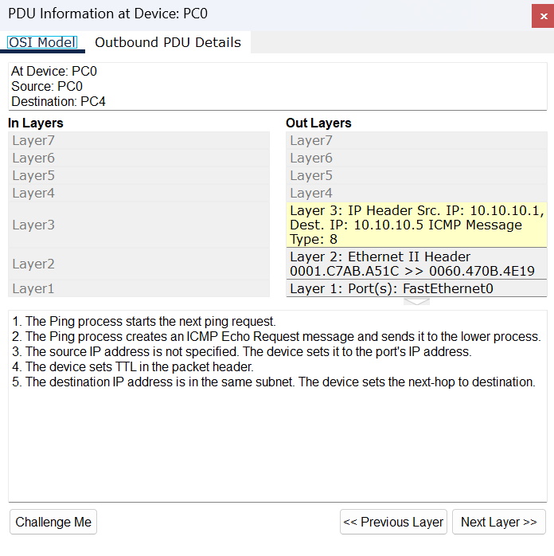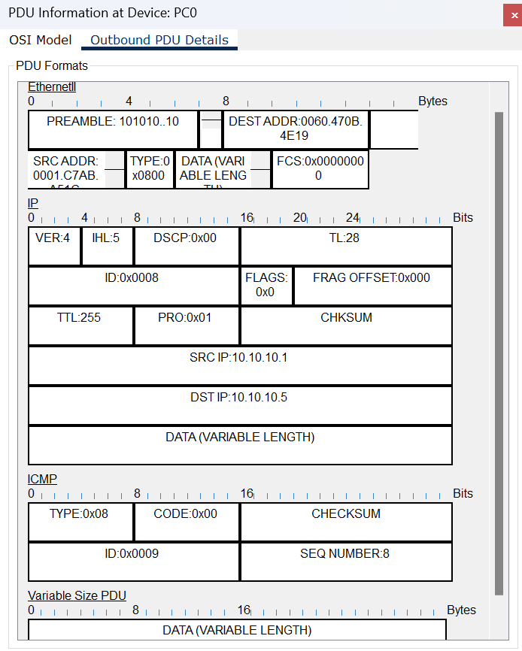

Fig 3.4: Protocol data unit at PC0

**Conclusion:**

* What a star topology is:
* Star topology connects all station via a single central station.
* How a star topology works:
* Data travels through the central station.
* Where a star topology is used:
* It is used in LANs.
* Pros and cons of using a star topology:

|  |  |  |
| --- | --- | --- |
| Pros |  | Cons |
| 1. New stations can be added or subtracted with the system keeping on. |  | 1. Network falls if the center device falls. |
| 1. Network fault detection is easeier. |  | 1. More cables are needed. |
| 1. Use of intelligent hub or switch helps in workload monitoring. |  | 1. Data transmission rate decreases if the number of station increases. |
| 1. A single peripheral faulty station does not affect the network. |  | 1. Performance depends on the central device. |
| 1. Multiple types of cables can be ued in a network. |  |

**Experiment No.: 4**

**Experiment Title:** Simulating Mesh Topology using Cisco Packet Tracer

**Objectives:**

* To learn what a Mesh topology is
* How a Mesh topology works
* Where a Mesh topology is used
* Advantages and disadvantages of Mesh topology

**Discussion:**

Physical topology is the geometric representation of all the nodes and interconnections in a network.

A Mesh topology is a physical topology where all the nodes are connected directly to every other nodes. Data can be directly sent to one node to the other.

**Methodology:**

* Create the network topology.
* Configuration of the Network Nodes.
* Choose the Statistics.
* Run the Simulation.
* Analysis of the Results.

**Working procedure:**

1. **Giving the geometric shape of the topology**

Connecting 4 PCs to 4 switches, 1 per each, with straight through copper cable, as they are different typed devices and then connecting each switch to other 3 switches with cross over copper cable, as they are same type of devices.

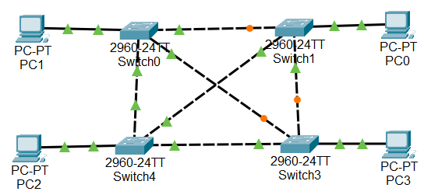

Fig 4.1: Simulating a mesh topology in CPT

1. **Configuring the PCs**
   1. Configure PC0, PC1, PC2, PC3, PC4 with the following IP addresses and Subnet Masks

|  |  |  |
| --- | --- | --- |
| **Host** | **IP Address** | **Subnet Mask** |
| PC0 | 10.10.10.1 | 255.0.0.0 |
| PC1 | 10.10.10.2 | 255.0.0.0 |
| PC2 | 10.10.10.3 | 255.0.0.0 |
| PC3 | 10.10.10.4 | 255.0.0.0 |

1. **Sending data across PCs**
   1. Connection tests across PCs

Ping PCs by there IP addresses from another PC in Command Prompt, one after another. If connection is there, four replies will come.

Command: ping<space>’IP address of some other PC’



Fig 4.2: Pinging PC4 from PC0

1. **Simulation:**



Fig 4.3: Successful packets travel across PCs

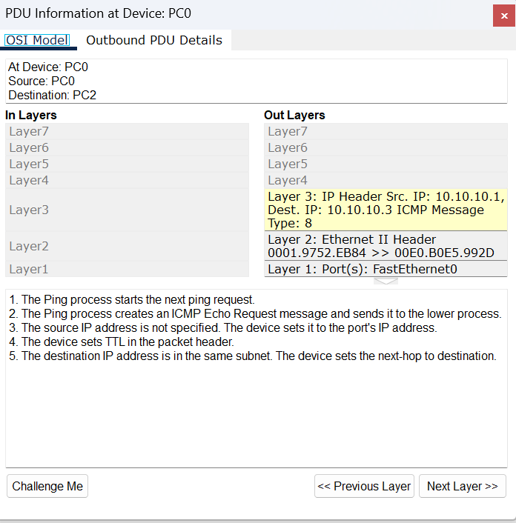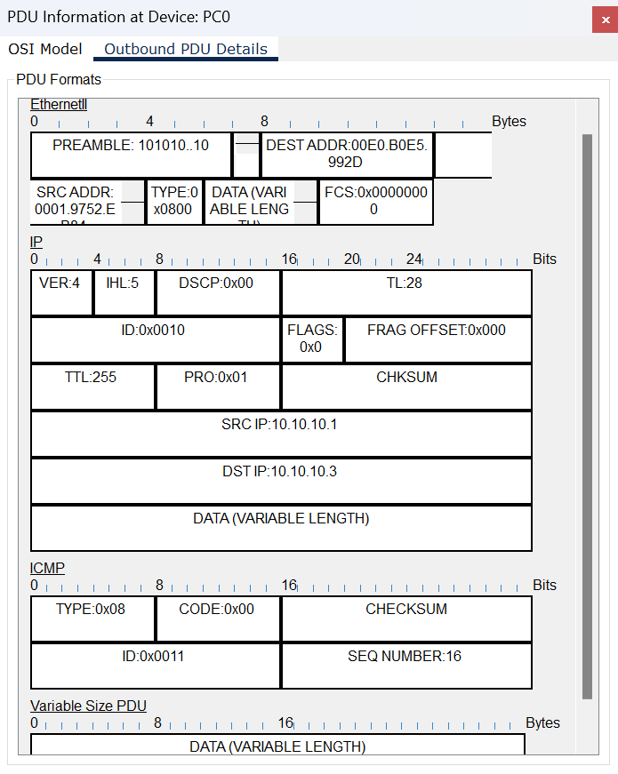

Fig 4.4: PDU(protocol data unit) details at PC0

**Conclusion:**

* What a mesh topology is:
* A Mesh topology is a physical topology where all the nodes are connected directly to every other nodes.
* More practical mesh topology is partial mesh topology.
* How a mesh topology works:
* Data can be directly sent to one node to the other.
* Where a mesh topology is used:
* Nearly in every network.
* Pros and cons of using a bus topology:

|  |  |  |
| --- | --- | --- |
| Pros |  | Cons |
| 1. Data communication is much more reliable. |  | 1. Installation and configuration is quite complex. |
| 1. Any network problem can be easily solved. |  | 1. Expensive. |
| 1. Data transmission rate is hight. |  | 1. Maintenance needs are challenging. |
| 1. There is no traffic problem as there is a dedicated point to point links in every station. |  | 1. High risk of redundant connections. |
| 1. Provides high privacy and security. |  |
| 1. Adding new devices won’t disrupt data transmission. |  |

**Lab Conclusion:**

From this lab we got to know about,

* Bus topology
* An economical topology, good for small networks, where stations are connected by one single backbone.
* Ring topology
* A centerless topology, used in LANs and WANs, where stations through interconnection creates a circular data-transmission path.
* Star topology
* A topology, used in LANs, where all the stations are connected to a single center station.
* Mesh topology
* An expensive and complex topology where each station has direct point-to-point connection to every other station.